参考学习：http://spark.apache.org/docs/latest/streaming-programming-guide.html
Discretized Stream是Spark Streaming的基础抽象，代表持续性的数据流和经过各种Spark原语操作后的结果数据流。在内部实现上，DStream是一系列连续的RDD来表示。每个RDD含有一段时间间隔内的数据。

使用run-example中的streaming.NetworkWordCount
spark-master执行./bin/run-example streaming.NetworkWordCount 172.18.0.1 12345
172.18.0.1主机执行 nc -lkp 12345 并随便输入一些单词
得到下图：
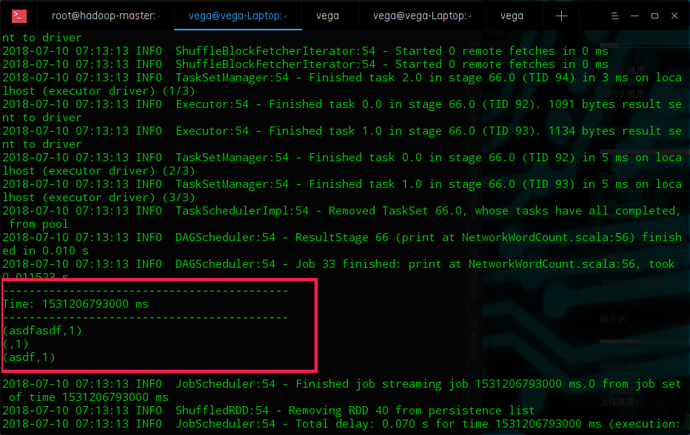

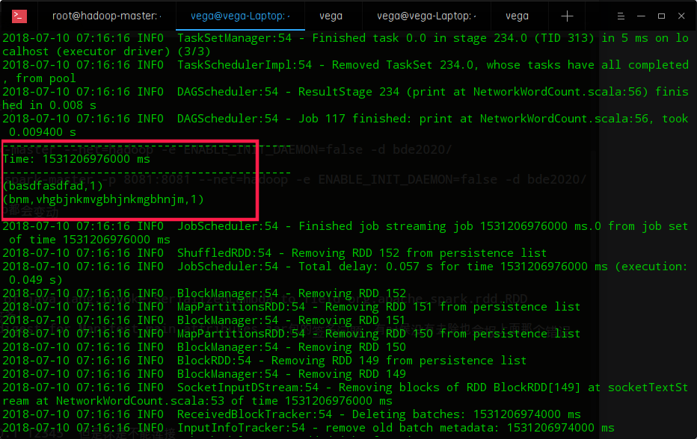

自己编写程序：

import org.apache.spark.SparkConf
import org.apache.spark.streaming.{Seconds, StreamingContext}
object SparkStream {
def main(args: Array[String]): Unit = {
val conf = new SparkConf().setAppName("SparkStream").setMaster("local[3]")
val streamingContext = new StreamingContext(conf,Seconds(20));
val inputStream = streamingContext.socketTextStream("172.18.0.1",8888)
val countStream = inputStream.flatMap(_.split(" ")).map((_,1)).reduceByKey(_+_)
countStream.print()
streamingContext.start()
streamingContext.awaitTermination()
}
}

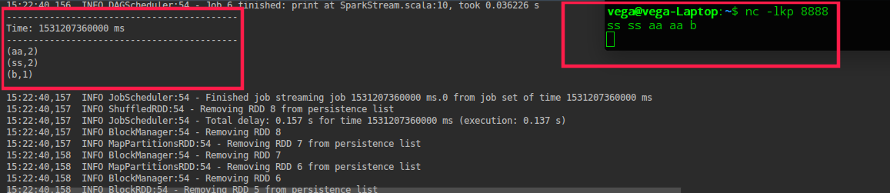

使用updateStateByKey实现累加：
import org.apache.spark.SparkConf
import org.apache.spark.streaming.{Seconds, StreamingContext}
object SparkStream {
def main(args: Array[String]): Unit = {
val conf = new SparkConf().setAppName("SparkStream").setMaster("local[3]")
val streamingContext = new StreamingContext(conf,Seconds(10));
streamingContext.checkpoint("/tmp")
val inputStream = streamingContext.socketTextStream("172.18.0.1",8888)
val updateFunc = (seq :Seq[Int] , op:Option[Int]) => Some(op.getOrElse(0) + seq.sum)
val countStream = inputStream.flatMap(_.split(" ")).map((_,1)).reduceByKey(_+_).updateStateByKey(updateFunc)
countStream.print()
streamingContext.start()
streamingContext.awaitTermination()
}
}

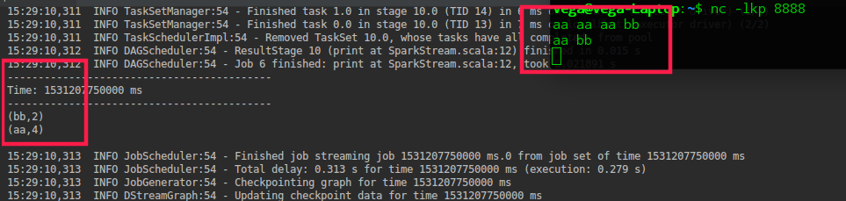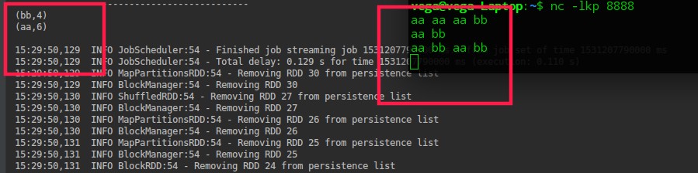

窗口函数：
import org.apache.spark.SparkConf
import org.apache.spark.streaming.{Seconds, StreamingContext}
object SparkStream {
def main(args: Array[String]): Unit = {
val conf = new SparkConf().setAppName("SparkStream").setMaster("local[3]")
val streamingContext = new StreamingContext(conf,Seconds(3));
streamingContext.checkpoint( "/tmp");
val inputStream = streamingContext.socketTextStream("localhost",8888)
val updateFunc = (seq :Seq[Int] , op:Option[Int]) => Some(op.getOrElse(0) + seq.sum)
val countStream = inputStream.flatMap(_.split(" ")).countByWindow(Seconds(6),Seconds(3))
countStream.print()
streamingContext.start()
streamingContext.awaitTermination()
}
}

